**PROJECT DETAILS:**

**PROJECT DESCRIPTION:**

**` ZoteroBib is a free, web-based citation generator from the same team that developed Zotero. ZoteroBib, or Zbib, was released in 2018 and is maintained by the Corporation for Digital Scholarship (also known as “Digital Scholar”). The Corporation for Digital Scholarship is a nonprofit organization founded in 2009 that is dedicated to the development of software and services for researchers and cultural heritage institutions.**

**ZoteroBib helps you build a bibliography instantly from any computer or device, without creating an account or installing any software. It’s brought to you by the team behind Zotero, the powerful open-source research tool recommended by thousands of universities worldwide, so you can trust it to help you seamlessly add sources and produce perfect bibliographies. If you need to reuse sources across multiple projects or build a shared research library, we recommend using Zotero instead.**

**BIBLIOGRAPHY:**

**A bibliography is a list of works (such as books and articles) written on a particular subject or by a particular author. Adjective: bibliographic. Also known as a list of works cited, a bibliography may appear at the end of a book, report, online presentation, or research paper**

**USES OF BIBLIOGRAPHY:**

**The main purpose of a bibliography entry is to give credit to authors whose work you've consulted in your research. It also makes it easy for a reader to find out more about your topic by delving into the research that you used to write your paper.**

**COMPONENTS OF THE APPLICATION**

**1) SEARCH BOX:**

**A Search Textbox was placed in the page at the top of the page. We can use the following keywords to perform search.**

**• URL - Uniform Resource Locator is the hyperlink or web address of the work you are citing**

**• DOI - . Digital Object Identifier - DOI is a unique alphanumeric string that identifies content and provides a persistent link to its location on the internet.**

**• ISBN - the International Standard Book Number (ISBN) is a unique International Publisher's Identifier number, which is meant for monograph publications.**

**ISBNs are not included in works-cited-list entries for a number of reasons. First, ISBNs were developed only in the second half of the twentieth century, so older books won't have them. Second, an ISBN doesn't help readers directly access the book's content**

**• PPMID -PubMed Unique Identifier. This is a 1 to 8 digit number assigned to all records in PubMed. In a PubMed record, the PMID number is located at the bottom left of the record. Some citation styles include the PMID near the end.**

**• Title - Notice article titles are put in quotation marks and only the publication title is italicized or underlined. Author Last Name, Author First Name. (Publication Date-could be more than a year) “Article Title.”Publication Title, Vol.**

**2) BUTTON (CITE):**

* **Cite is used to fetch text based on (1)**
* **It’s given name is Cite**

**3) BUTTON (MANUAL ENTRY):**

**♣ This button helps to navigate to the next window**

**♣ I have attached a screenshot (Image 1) (Page 4)**

**♣ In the next window, we find:**

**(1) Two Dropdown or Combo Box**

**(2) Twenty Three Text Box**

**(3) Four Command Box**

**Image 1**

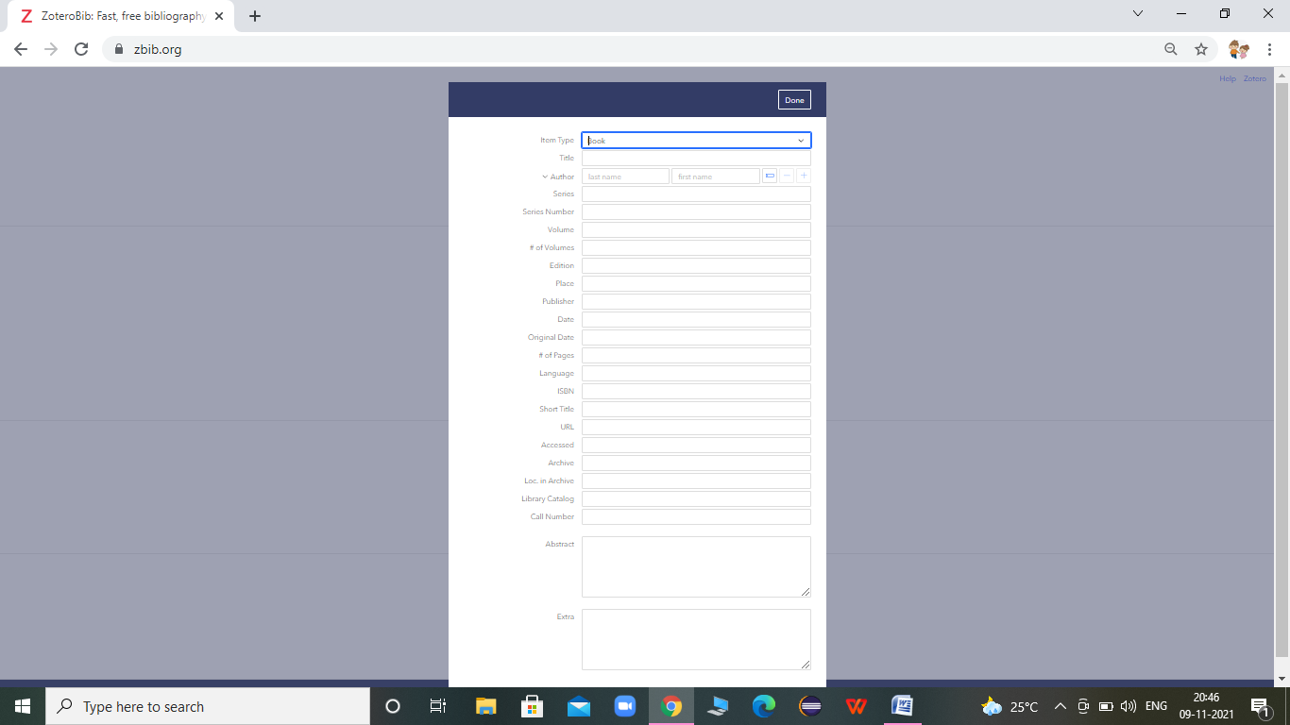

**4) CONTAINER:**

**Its help to add a source, paste or type its URL, ISBN, DOI, PMID, Xiv ID, or title into the search box above.**

**Using Robotic Process Automation as an example, I attached an image reference (Image 2) (Page No 5) after searching in the textbox. The list of results is shown s a table which contains related item or reference book.  After selecting any possible option, it moves on to the next step.**

**Image-2:**

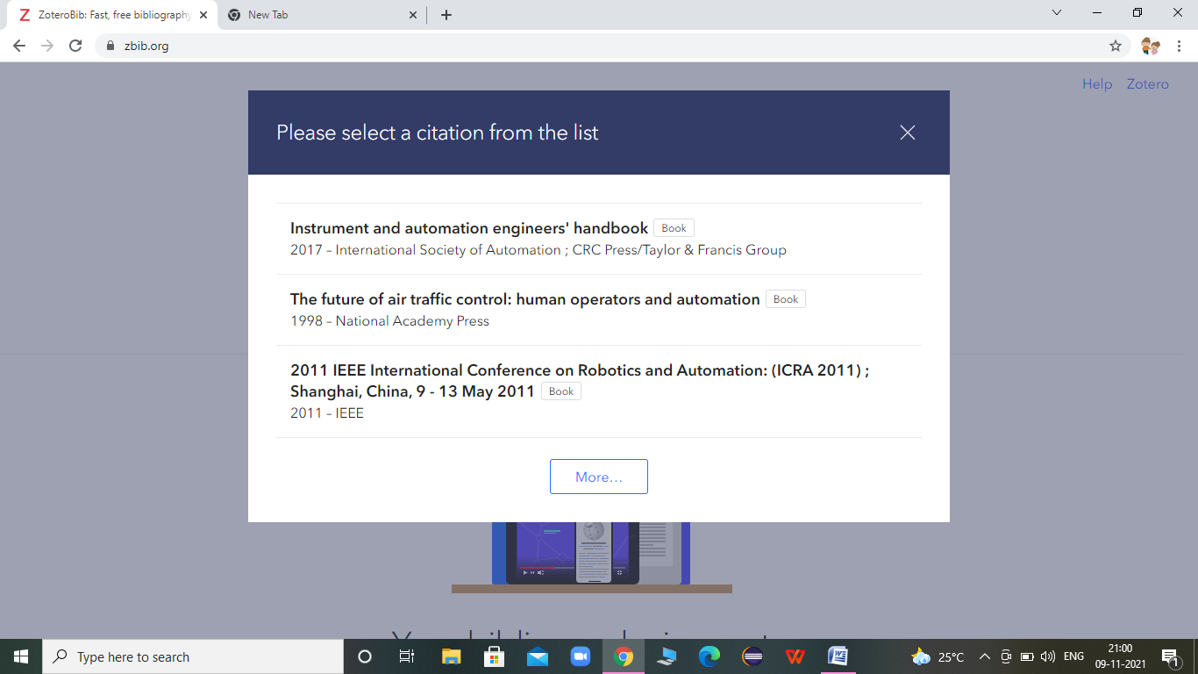

**It then displays three command boxes: Close, Edit, and Delete (Image-3). After that, we have a Delete command box and a Copy option that allows us to copy the text and delete the search option.**

**Image – 3**

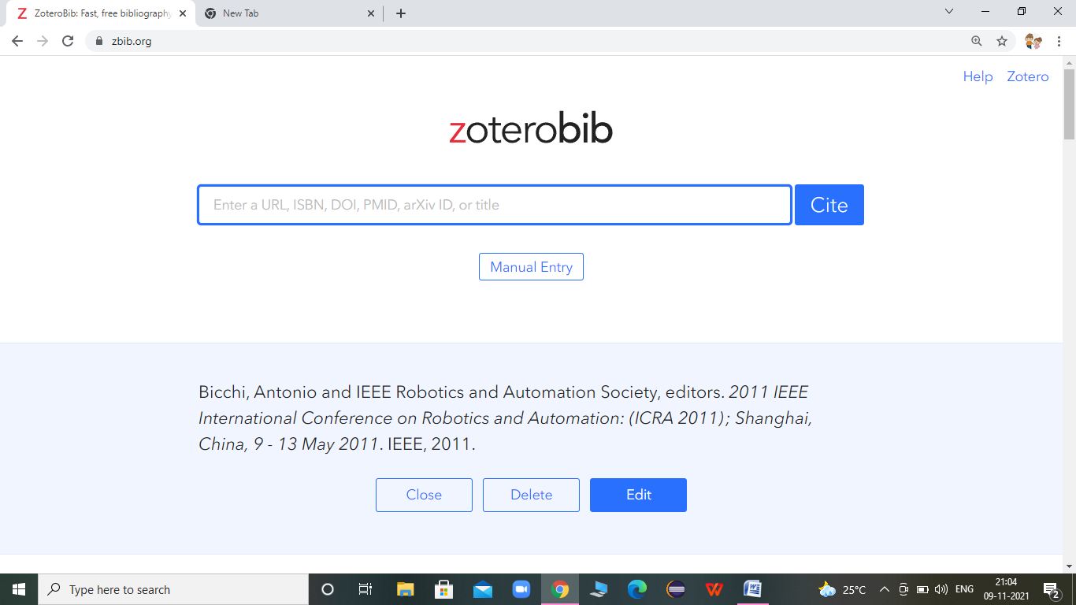

**5) EXPORT:**

**Its contain one dropdown box with the option of ref (Image-4)**

* **Download RTF(all word)**
* **Copy HTML**
* **Download RIS**
* **Download Bis Tex**
* **Save to Zotero**

**Image-4**

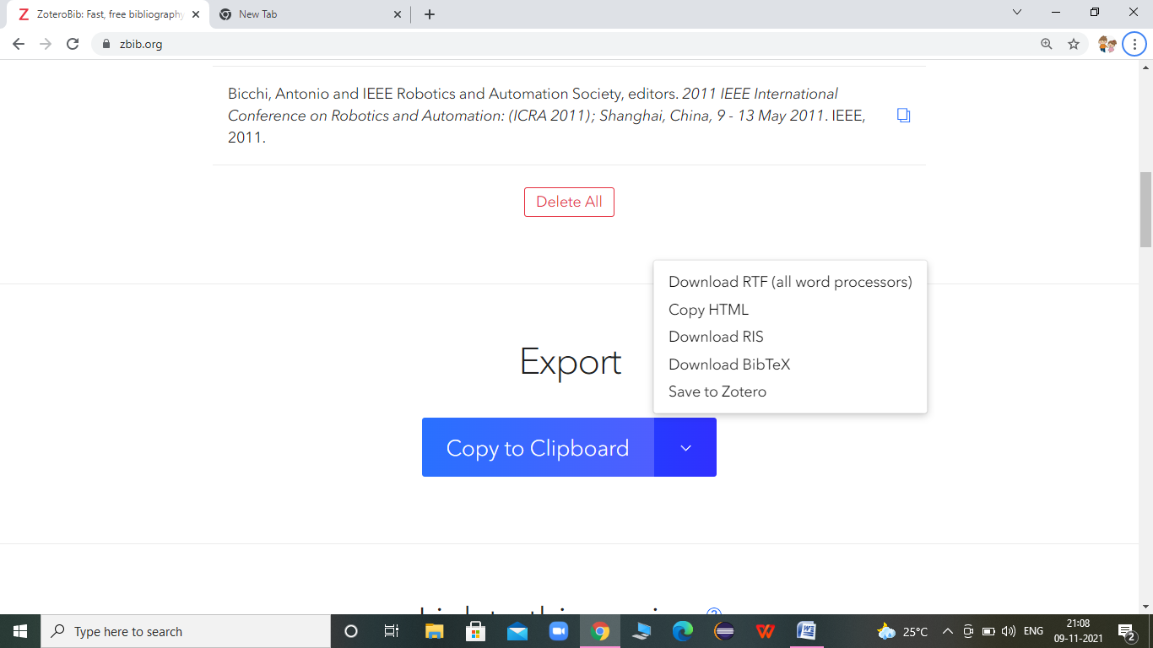

**6) LINK TO THIS VERSION:**

* **Its contains button with name CREATE. It helps to create link of search BIBLIOGRAPHY**
* **Its contains two buttons. One is to copy and the other one is to view.**

**Copy help to:**

* **For example my search results**[**https://zbib.org/3f480c53ed454e4a8cbfc6105e43f70b**](https://zbib.org/3f480c53ed454e4a8cbfc6105e43f70b)
* **View goes to next window shown in( Image-5)**

**Image - 5**

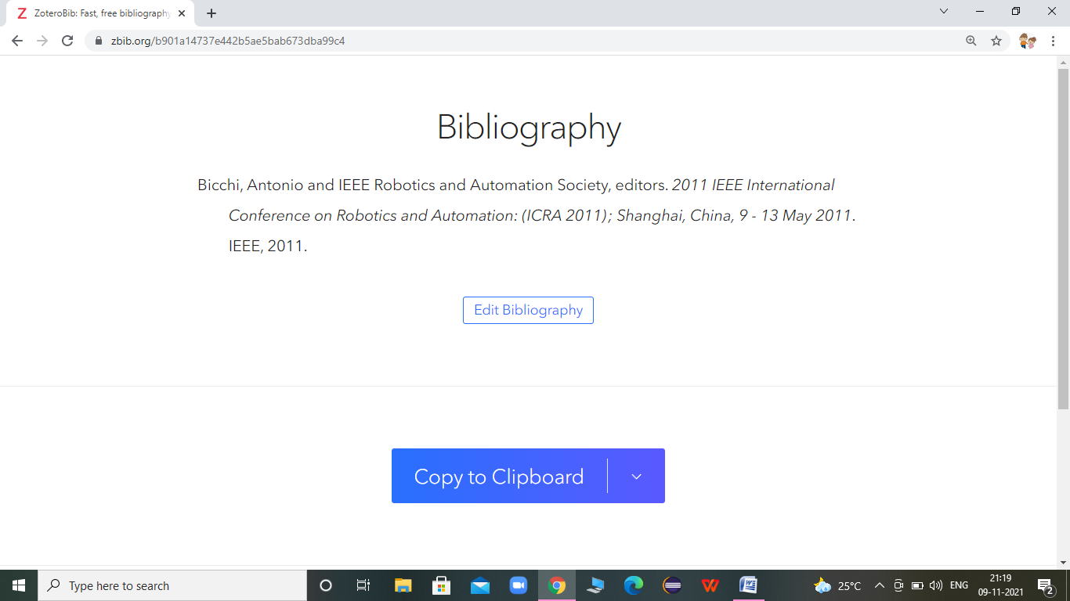

**7) Awesome!  Let’s Start:**

**When we click on this button, it goes to that top of the page and displays the search bar.**

**Other Details:**

**In the bottom of the page, details regarding the Application are displayed.**

**There is also an FAQ section. When we click on it, it goes to the next page.**

**TESTING:**

**The following features were tested:**

**1. Performed Search using different keywords such as URL, ISBN etc.**

**2. Verified the search results obtained and added them to the Bibliography.**

**3. Performed Edit, Delete, Copy and Save actions on them.**

**4. Added a record manually by using the Manual Entry feature.**

**5. Verified navigating to multiple pages.**

**BUGS**

**BUGS:**

**As part of testing, the following bugs were identified.**

**BUG 1:**

**The Application does not open in Chrome Browser in Windows 7.**

**BUG it opens in Firefox browser in Windows 7.**

**BUG 2:**

**When I perform a search - for example - "Robotic Process Automation" - it shows me a table as a result. In this table, in the last row, MORE - button is present. After clicking the button, I got more options, but there was an error message**

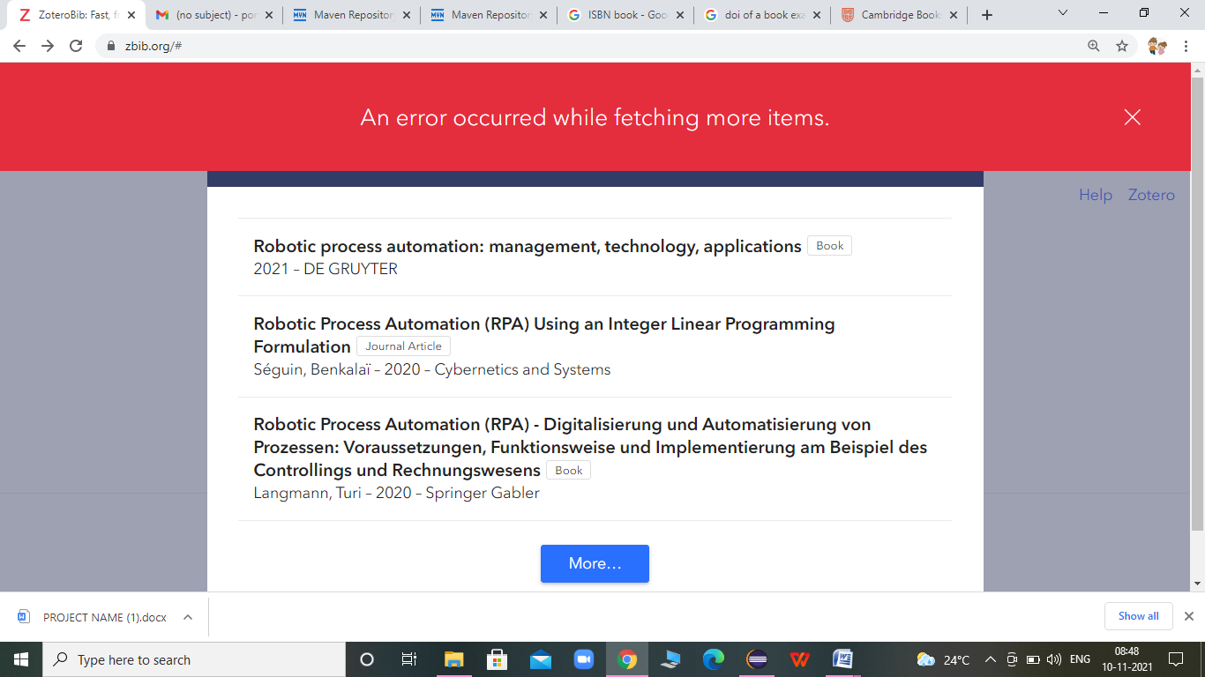

**BUG 3**

**Textbox with Date accepts alphabetic and special characters, but it should accept numerical dates, so it is a bug**



**BUG 4:**

**Textbox with Original Date accepts alphabetic and special characters, but it should accept numerical dates, so it is a bug**



**BUG 5:**

**In # of Pages Text Box accepts alphabet and special character also**

**Page Number always in numerical so it is also BUG**

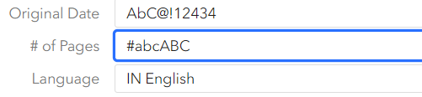

**BUG 6:**

**When we press Back button in browser, it most of the pages, it does not go to the previous page. Instead it goes out of the Application.**

**BIBLIOGRAPHY**

**WEBBSITES:**

**I also get detail form websites**

**• Google**

**• YouTube**

**• ZoteroBib**

**Tools:**

**• Chrome Browser**

**• Firefox Browser**